**Gestalt Theory**

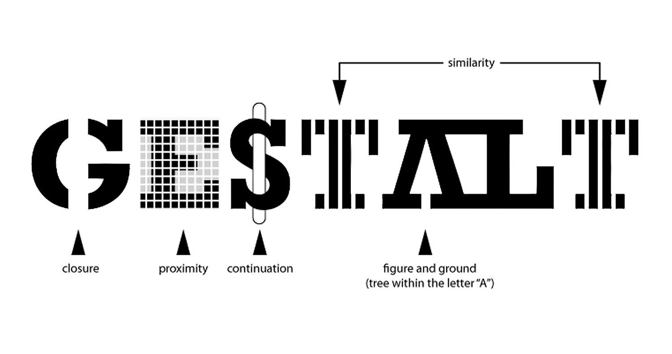

This week let's take a look at some industry-standard theories that play a vital role in developing good UI design. Later we will learn how to create our first UI design Moodboard.

Good design often starts with a good eye for **space, typography, and relationships between design elements**. There’s a distinct design theory that backs up that thinking – **Gestalt Theory.**

Simply, the concept pertains to visual perception, how elements are actually seen by users, and what this means in terms of the overall design. The concept dates to the 1920s and is rooted in a German word meaning “shape or form.” The idea that the “whole is the sum of the parts” comes from the principles of Gestalt. (Source: [Efficient UX](https://www.secretstache.com/blog/ux-gestalt-theory/)) <https://www.secretstache.com/blog/ux-gestalt-theory/>

Please watch the video lesson to learn some basic interface design strategies pertaining to Gestalt Psychology

<https://youtu.be/Mh5jYCPteg4>

It’s important to understand and apply the Gestalt principles when you are working on a design project because even when you are not planning for it the users will see elements and groupings based on these principles.

If you understand how the human mind works, it’s easier to direct people’s attention to the right place. And keeping these principles top-of-mind will help you keep the user at the center of your product development process. (Source: [Toptal](https://www.toptal.com/designers/ui/gestalt-principles-of-design)) <https://www.toptal.com/designers/ui/gestalt-principles-of-design>